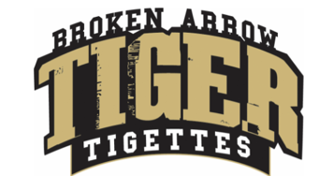
Tigette Booster Club Meeting
November 6th, 2023

- Open Meeting
- Minutes from last meeting (posted on website)
- Executive Board Business
- Varsity Business
- JV Business
- 9th Grade Business
- 8th Grade Business
- Treasurers (updates will be posted after statement is received)
- Events
  - TeamChristmas Parties - Saturday December 2, 2023
  - NEW DATES for Tigette Banquets - Varsity, Friday March 8th. JV, Tuesday March 12th.
- Fundraising
  - Panera Monday November 13th 4:00 - 8:00 PM, 2201 W. Detroit St. - Use Code FUND4U
  - Awaiting payments from Oktoberfest.
  - Please make sure you get your plaques to your sponsors and email pictures to tigettebooster@gmail.com
- Competitions
  - State OSSAA - Friday November 10th
  - DTU Nov 17th - 19th
  - OSDTDA State - December 8th - 9th k
  - DTU 2 - January 27th at UMAC
  - Nationals - February 7th -13h (Varsity and JV only, in Orlando)
- Community Service
- Christmas Cards for Nursing Home - December 12th (girls will make cards in Student Union during Booster Club Meeting, Cards will be delivered on Wednesday evening December 13th) (Please purchase at least one pair of non-slip socks to be take with cards for the residents)
13. Important Dates
- Game Day State - November 10th
- Tigette Panera Bread Fundraiser Night - November 13th
- Tigette Showoff Showcase - November 13th at Oneta Ridge
- DTU - November 17th - 19th Tiger Field House
- Thanksgiving Break - November 20th - 24th
- OSDTDA State - December 8th - 9th
- Christmas Cards for Nursing Home - December 12th, Delivery December 13th
- DTU 2 - January 27th (UMAC)
- Nationals - February 7th - 13th (Orlando, FL)

