Accessing Westwood
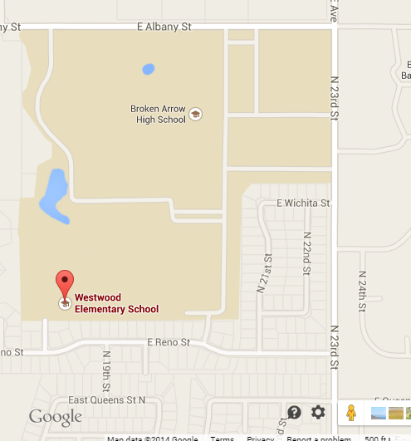Enter Here

